EmComMap 0.4a User Guide

Dan Ruderman (K6OAT)

[emcommap@gmail.com](mailto:emcommap@gmail.com)

December 8, 2018

1. Introduction

As digital modes become more pervasive for emergency communications, we can begin using more advanced operating methods. Additionally, software advances make user interaction within the browser more functional. These advances include interactive maps and sync-able browser-side databases. EmComMap leverages these technologies to enable shared, map-based situational awareness part of emergency communications.

Briefly, EmComMap provides an internet-based communicator designed for emergency communications. It focuses on a map of the incident area, and allows users to specify locations related to messages and operators. It provides functionality typical of Amateur Radio Emergency Service (ARES) operation, such as specifying traffic precedence and exporting traffic logs. Additionally, it acts as a convenient way to collect and summarize information about specific locations. It is intended for use either as a method to accumulate situational awareness (for example, used by a net control operator), or as a primary communication platform over mesh.

1. Accessing and signing on

EmComMap is currently served on the AREDN mesh through the node *K6OAT-RocketM5-172.local.mesh.* Click on *EmComMap (experimental)* to launch. It has been tested on the browsers Chrome, Firefox, and Safari.

The main page will look like this:

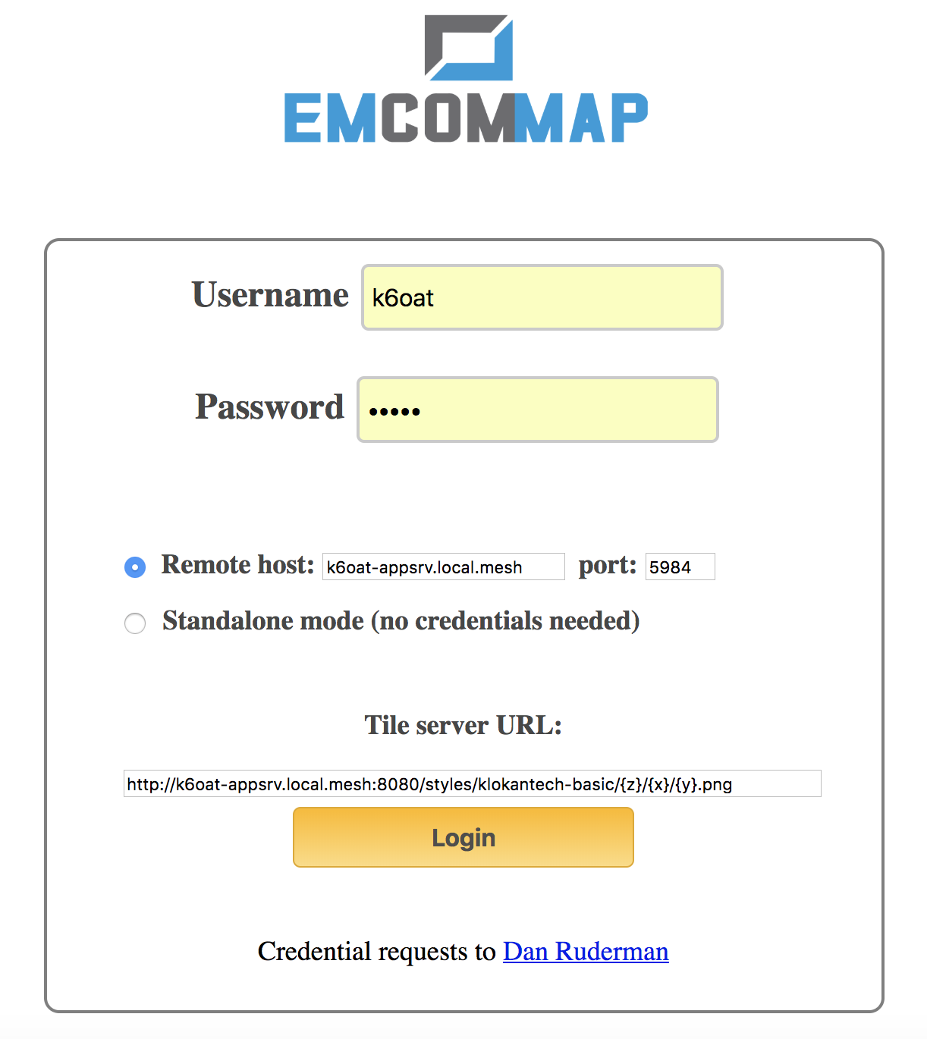

You may be able to log in as *guest* with password *guest*. If you would like personal credentials, contact the host administrator. Unless you have access to a different host database and map tile server, use the default database host (in *Remote host*) and tile server URL. Click the Login button. In case of difficulty logging in, see if you can capture any error messages that appear on the javascript console within your browser and forward to the app developers ([emcommap@gmail.com)](mailto:emcommap@gmail.com)). Alternatively to working in a multi-operator context, you can operate in standalone mode by clicking the *Standalone mode* radio button. This will work just with data that are local to your browser and not shared with others, so it’s a good way to either experiment or to scribe traffic for a voice net. When using standalone mode, be very careful not to clear your browser cache, or you will lose all your data!

1. Choosing or creating an incident

Once logged in, you will be able to choose and existing incident or create one of your own. The page should look like this:

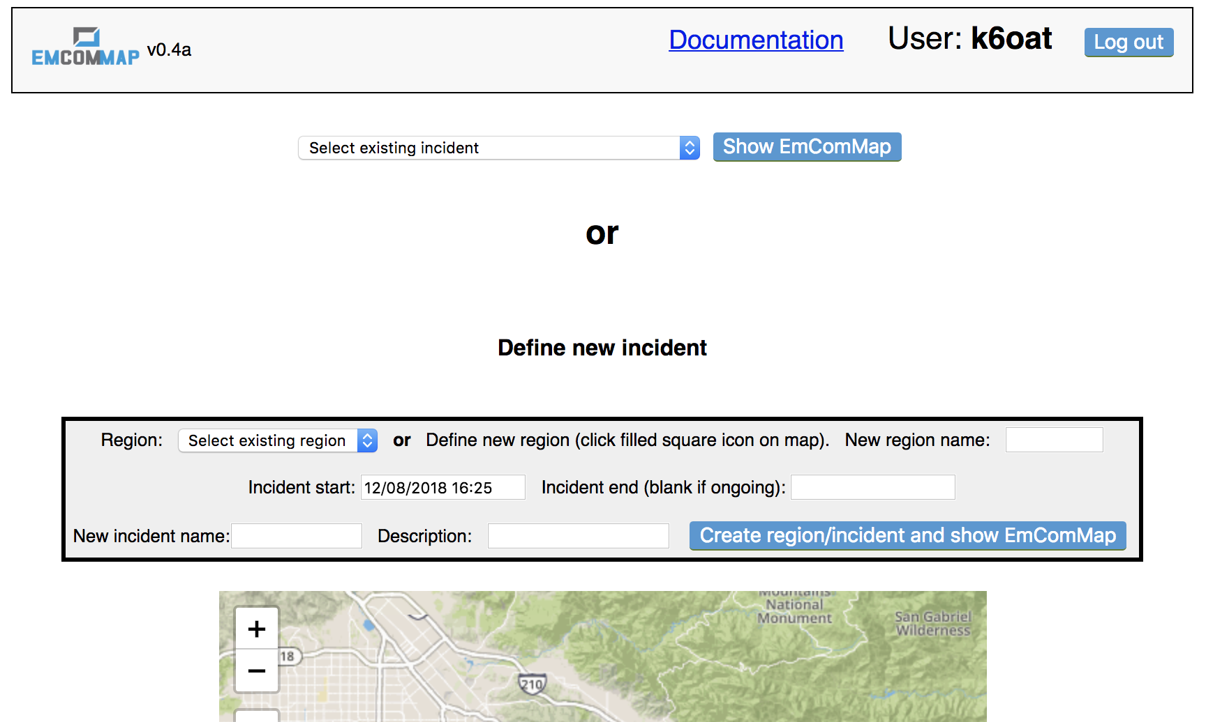

If the selection box entitled “Select existing incident” does not contain any incidents, then you may need to wait a few seconds for the database to sync (or try refreshing the page). If it stays empty, then there may be no incidents yet defined, so that you will need to define one (see below). You may select an existing incident and click the “Show EmComMap” button.

You create your own incident using the box in the middle of the page. You can select an existing region, incident start time, and (optionally) incident end time. An ongoing incident has no end time specified (or you can specify an end time that is far enough in the future to likely postdate the incident). Give the incident a name (e.g. *20181114 Burbank Fire*) and description. Then click the “*Create incident and show EmComMap*” button.

If you wish to define your own rectangular region on the map, then scroll down to the map area, press the box with the filled black square on the left, and then drag a rectangle on the map. If you wish to edit the rectangle once created, press the button that has the pen in the unfilled rectangle. If you wish to delete the rectangle, click the trashcan button when the rectangle is selected. Once your region is defined, you can name it in the “*New region name*” text field and then add incident timing information. Once you click on “*Create region/incident and show EmComMap*”, the new region will be defined in the database along with the new incident.

1. Quick operating guide

Once the EmComMap application has loaded, your screen should look something like this:

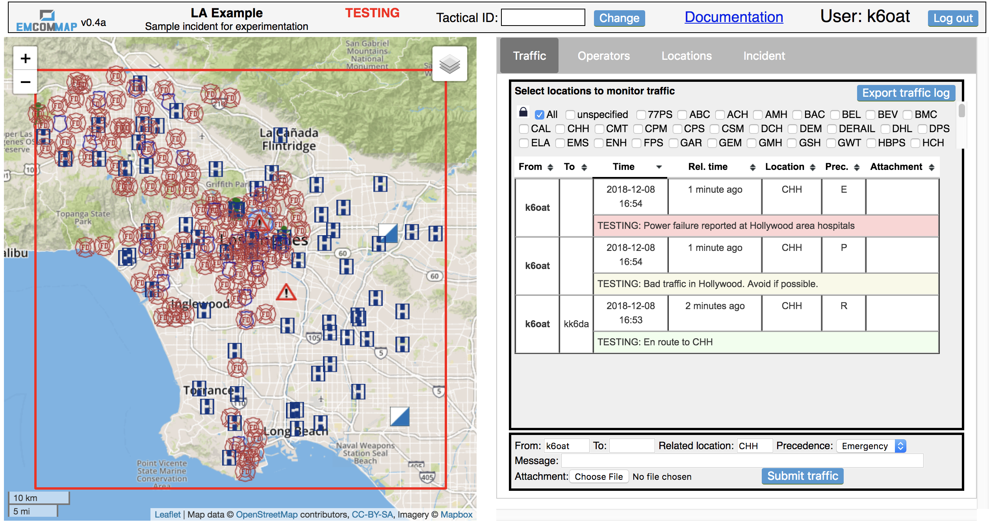

At the top shows who you are and the current incident. You may enter a tactical ID by pressing the “*Change*” button; you can alter it as often as needed. The left side displays a map of the incident’s region, with its rectangular border outlined in red. Locations outside this region and message traffic relevant to them are not displayed, allowing multiple unrelated incidents to be operationally segregated. If you wish to view multiple such regions simultaneously, then define a new region which contains all the regions of interest and then create a new incident based on that new region.

The map shows various locations with associated markers. Marker symbols are shown in Table 1. You may zoom into and out of the map using the + and – buttons on the upper left, and you may use the mouse to pan (some trackpad gestures will also allow zooming). Clicking on or hovering over the various markers will either transfer their information to the right-hand panel or show information as a tooltip near the pointer position.

|  |  |
| --- | --- |
| **Marker** | **Meaning** |
|  | Hospital |
|  | Police station |
|  | Fire department |
|  | Government facility |
|  | Incident command post |
|  | Incident |
|  | EmComMap operator |

**Table 1:** EmComMap marker symbols

On the right-hand side, there are four tabbed panes, ***Traffic****,* ***Operators****,* ***Locations,*** and ***Incident****.* In the figure above, the ***Traffic*** pane is displayed. You can see existing traffic in the table, with the text color coded by message precedence (green=routine, yellow=priority, red=emergency). You may send traffic of your own using the box at the bottom, which contains the *Submit traffic* button. If sending emergency traffic, you will be prompted to confirm prior to sending.

Below is an example of message information filled out prior to pressing the submit button:

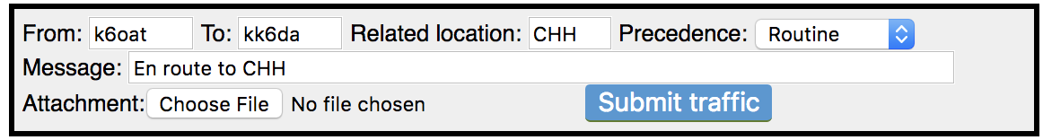

This message is being sent to the attention of *kk6da*, though everyone can view it (like sending voice traffic by radio). If you intend traffic for all operators, then leave the “*To*” field blank. The “*Related location*” is used to specify the label of a location about which the traffic is related. Once you press the submit button, the traffic should be displayed in the table above. This is the basic method for sending and receiving traffic.

1. A note on identifiers

To prevent capitalization issues in comparisons, operator identifiers (i.e. callsigns and tactical calls) are converted to lower case. Location labels, though, are not converted; they are typically in upper case (e.g. CHH).

1. Interacting with the map

The map can be panned and zoomed. Its geography is currently limited to the Southern California area around Los Angeles. Various markers decorate the map, corresponding to locations (e.g. hospitals, police, fire, operators). Some markers will display tooltip information when hovered over with the pointer. Others perform actions when clicked. For example, when you click on a location, that location’s coordinates and label are placed within various fields in the right-hand information area. Clicking on a location also selects that location for viewing only its traffic (if the location lock is unlocked to allow it). By copying information, the application attempts to discourage the typing in of callsigns and labels to prevent errors.

In the upper right corner of the map is an icon for manipulating layers. Clicking on it allows you to toggle the appearance of markers for different types of locations. This also toggles the appearance of message traffic corresponding to those locations in the traffic table (see below). Removing locations and traffic not relevant to a particular operator helps reduce visual clutter and distractions from extraneous traffic. Below is an example of a map region with the fire markers present (left) and removed (right), also showing the map layer selector tool.

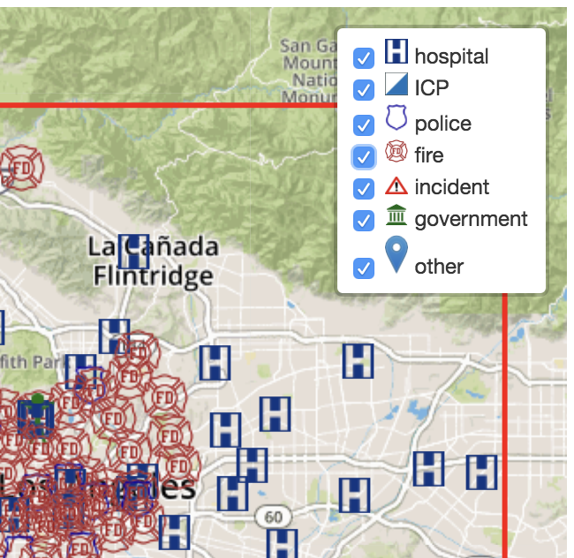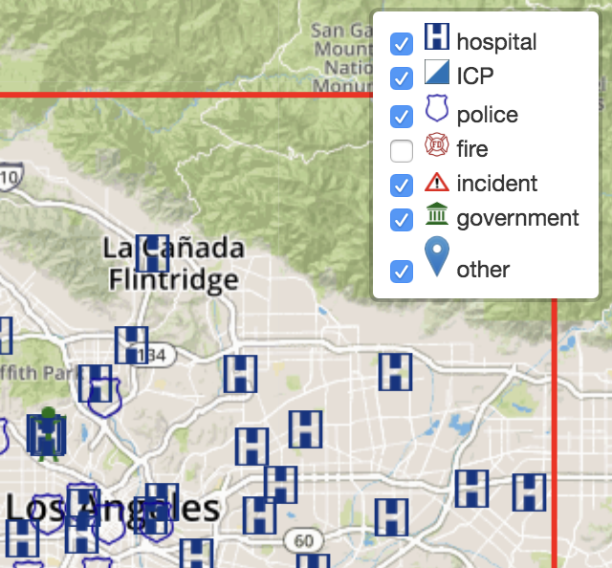

1. The Traffic pane

The traffic pane shows traffic from during the incident, possibly filtered based on selected locations. Each message has the following fields (some optional):

* 1. **From**: the message’s originator. In the absence of an assigned tactical ID, this will be the operator’s callsign. When a tactical ID is assigned to the originator, it will be displayed along with their individual callsign in parentheses. If the message was conveyed by a third party, then the *from* field will be appended with *[rly: callsign]*, showing the callsign of the originator. Clicking on either the *from* or *to* field will briefly highlight the named operator’s location on the map (if they have specified their location; see below).
  2. **To**: the message’s intended recipient. This is a freeform text field, though typically will contain a callsign or tactical ID. Clicking on an operator in the traffic table will automatically fill this field with their callsign (or tactical ID if specified). This is not only a convenience, but also limits spelling errors.
  3. **Time**: the time at which the message originated
  4. **Rel. Time**: An easy to parse relative time that the message originated (e.g. *about 2 minutes ago*).
  5. **Loc**.: location relevant to the message. This may be the location of the originator, or just the location that the message is about.
  6. **Prec**.: message precedence (R=routine, message text green; P=priority, message text yellow; E=emergency, message text red).
  7. **Attachment:** if the message has an associated attachment, this field displays the size of the attachment. Clicking on it will download the attachment.

When new traffic is received that relates to a particular location, that location will be briefly highlighted by a blinking circle.

Filtering traffic by location: You can select one or more locations of interest to filter traffic. First, ensure that the lock icon is open (it is closed by default). Then you can either click on a map location marker or a checkbox with the location’s label to select that location’s traffic. There are two special checkboxes. The first is *All*, which, when selected, will override all other checkboxes to display all traffic. The second is *unspecified*, which selects messages that have no specified location. Multiple checkboxes can be checked at one time. A convenient way to operate is keeping a few locations of interest checked while periodically toggling the *All* checkbox to view all other messages. The location checkboxes are initially in alphabetical order, but new locations added during the incident will appear at the end. Traffic is additionally filtered by the layers which are visible; if, for example, the fire station marker layer is hidden (using the layer selector tool), then all fire station traffic will be filtered out. **Note: emergency traffic is never filtered.**

Traffic log export: The *Export traffic log* button will export all incident traffic to a downloadable excel spreadsheet.

Sorting the table: The traffic table can be sorted on multiple columns by clicking on the column headers. You begin by sorting on the first column and then adding other columns by shift-clicking on their headers in sequence. Sort order can be reversed by additional clicks (or shift-clicks).

Sending traffic: You can send traffic using the entry form at the bottom of the pane. Enter values in the fields as described above. By default, the *from* field will be your callsign. If you have a tactcal ID it will automatically be included along with the message. If you are relaying traffic, set the *from* field to the callsign (or tactical ID) of the message originator. The *location* field is meant to convey a location of relevance for the message. If you click on a map marker, its location will be copied into this field. To add an attachment, click the *Choose file* button; file size is currently limited to 10MB. Finally, press *Submit traffic* to send.

Note that EmComMap’s security model is minimal. All users can read all messages, users can submit traffic on behalf of other users, users can report operator status of other users, etc. Security models are complex to administer and usually not intuitive for users. In an emergency situation the priority is to communicate, not struggle with software.

1. The Operators pane

This pane provides information about the current location and status of operators.

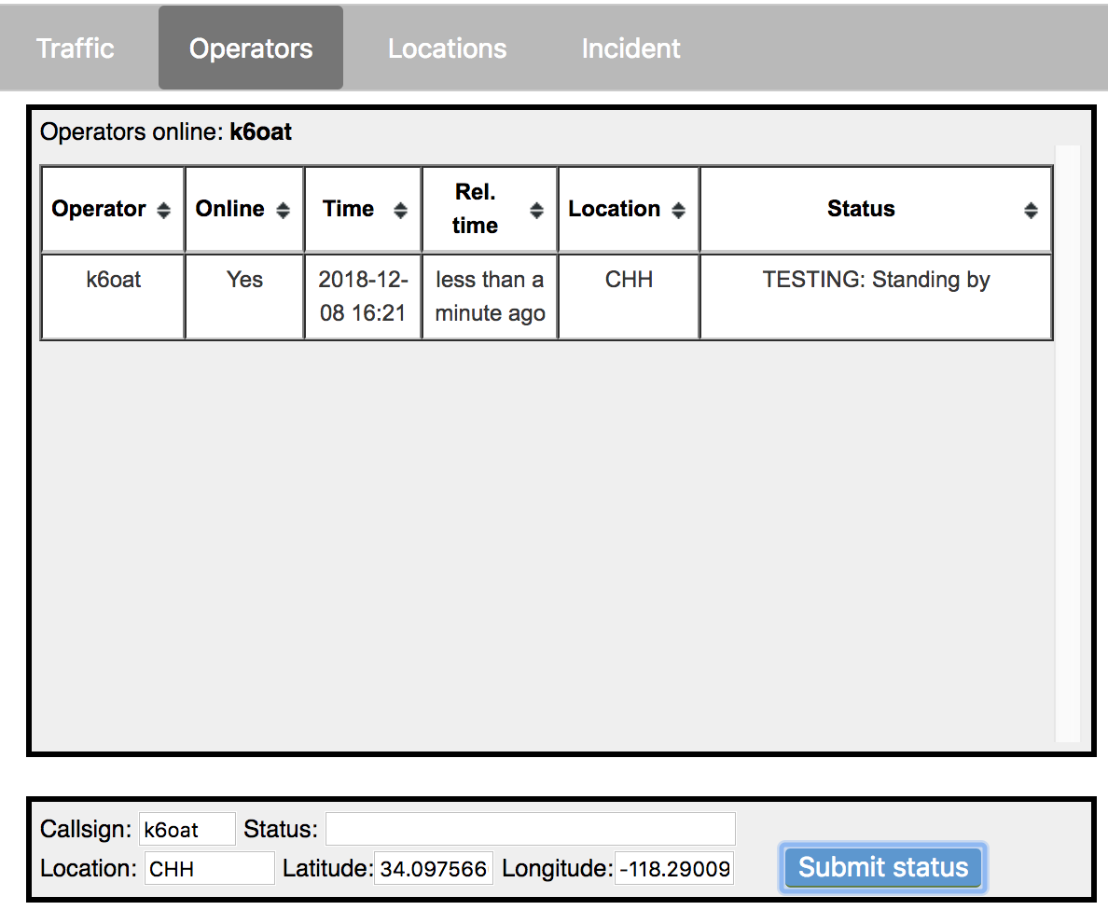

At the top is a list of operators currently online (from which an active application signal has propagated within the last 90 seconds). Below that is the operator status table. Like for traffic, this table has sortable columns. Additionally, hovering over a row will highlight the location of the corresponding operator on the map. The time indicated in the table corresponds to when the last status report was provided by the operator. Note that operator status is only shown if reported during the incident; status entered prior to the current incident is not shown because it is assumed out of date. If an operator is online, then their online status is shown as “*Yes*”. Note that if an operator has not submitted a status report (“checked in”) during the incident, they to not have a corresponding row in the table.

You may provide your status using the form at the bottom. You may also provide the status of another operator by changing the *Callsign* field to their callsign. The *Location,* *Latitude,* and *Longitude* fields will be filled in automatically by clicking on a map marker or a non-marker location. By closing the lock icon (by clicking on it), you can lock these three fields so they are not affected by additional map clicks, thus locking your location.

1. The Locations pane

This pane allows you to define new locations and to see/edit detailed status about individual locations. Clicking on a location’s map marker will display its information.

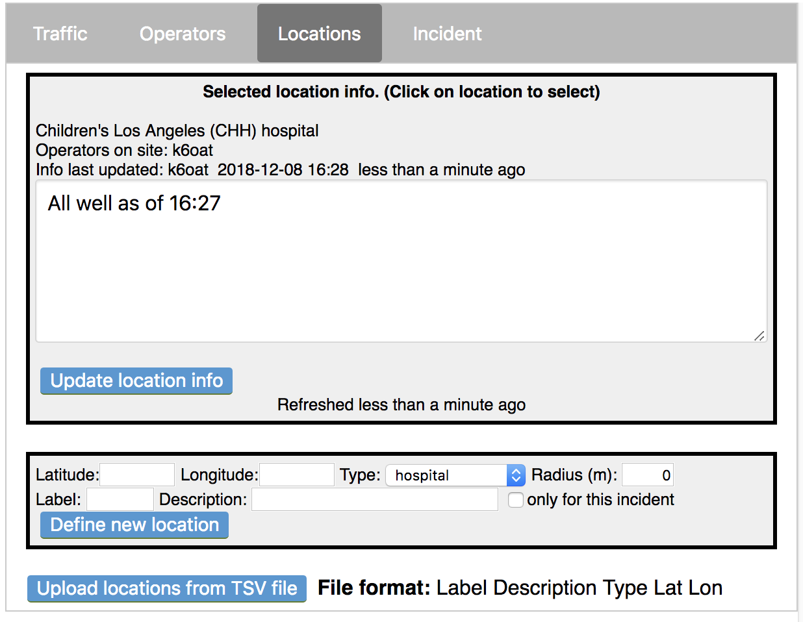

Information provided includes: location name, label, and type (e.g. hospital). It also shows which operators have listed themselves as at the location. In the main text area is freeform text which is editable by all operators. You may edit and click *Update location info* to record any changes. Note that any such information that has been entered prior to the incident start time is not shown; it is presumed to be outdated.

Defining a new location: If you want to define a new location (e.g. the site of an event, an incident command post, or a new permanent location), use the form at the bottom of the pane. The *Latitude* and *Longitude* fields can be filled in by clicking on the map (or by hand). The *type* is selectable from a drop-down. *Radius* is used to provide an approximate size of the location, which is drawn on the map as a circle. If the location is temporary, that is, not expected to be relevant once the incident has concluded, then check the “*only for this incident*” checkbox. Then the location will not be displayed in the EmComMap when viewing incidents prior to or after the incident in which the temporary location is defined. This is useful for locations representing emergency situations or command posts. For convenience, multiple permanent locations can be loaded from a text file using the *Upload locations from TSV file* button. The file contains the following tab-separated columns (with no header): label, description, type, latitude, longitude.

1. The Incident pane

The Incident pane allows users to update the incident status in a single text area. It also enables changing the incident description, start time, and end time. Note that you cannot revise the start time to be later than is currently set or the end time to be earlier than currently set. This is so no information collected previously will get filtered out from a redefinition of the incident’s timing. Click *Update incident info* to commit your changes.

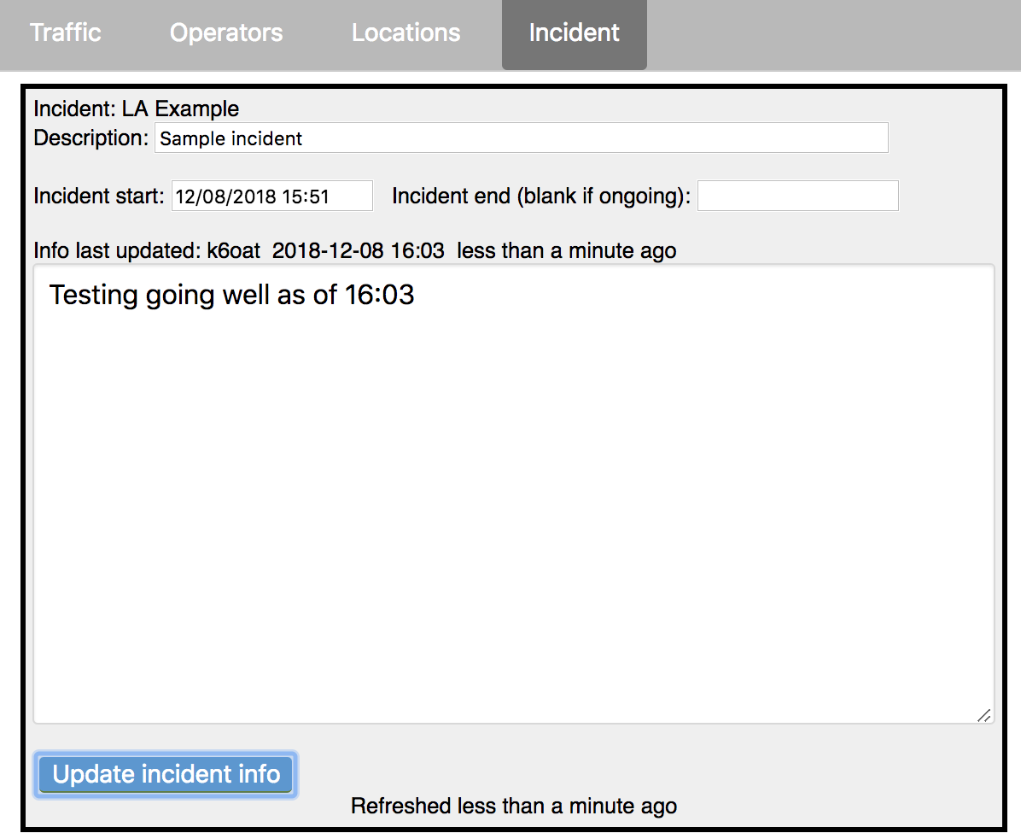

1. Troubleshooting

EmComMap is beta software, and so no doubt has a number of hiccups and bugs. Some remedies and known problems are outlined here.

* 1. **Unable to log in**. Password is reported as incorrect, even though you know it’s right. This is likely a problem establishing communications with the database (which authenticates user credentials). See if you can look at the javascript console on your browser (often found under “developer tools” in a menu). Please report any error text to the author for debugging.
  2. **Traffic table disappears**. This happens sometimes when switching between panes. Refreshing the web page should fix this.
  3. **Some dates/times appear incorrect or in the future**.Each user’s message timestamps originate from their own browsers. There is no master timekeeper. So if a user’s clock is in correct, so will be the time on their messages (perhaps even showing up as future times).
  4. **Map markers overlap, and you can’t click on the one you want**. This can happen when an operator places themselves at a permanent location, and the two markers are drawn in the same map location. The only current way to address this is to type the location’s label in the location field of operator status but then click on a location just adjacent to the location’s symbol, at high zoom. That way your operator symbol will not overlap at high enough zoom.
  5. **Changes to text information about a location or the incident were lost**.When multiple users simultaneously modify the same information, data conflicts may arise and only one set of changes is retained. This can also happen if users are isolated for a length of time due to communication failures: when the databases reestablish contact, conflicting changes will be resolved by randomly selecting one set of information (this is part of the underlying database software employed by EmComMap). Because of this potential issue with revising common information, we recommend that critical information be sent as traffic rather than being conveyed in common text areas. Such incidents are expected to be rare when communications are reliable; future releases may be able to recognize and report these issues.

1. Glossary
   * **Region**: a rectangular geographic area (oriented along latitude/longitude axes) with an associated name. Note: if a region contains the -180 degree meridian, the software will not interpret it correctly.
   * **Incident**: a region and associated time interval. The ending time may be unspecified, meaning an ongoing incident, but there must always be a start time. Message traffic that is outside the region or the time interval will not be displayed.
   * **Operator**: an EmComMap user
   * **Callsign**: the unique identifier of an operator
   * **Tactical ID**: the identifier for a given role (e.g. “lead”), which may be assigned to different operators at different times, but generally only one operator at a given time.
   * **Location**: a location with fixed latitude/longitude. It may have an associated label, description, and type (e.g. hospital). Locations can be either permanent (e.g. a hospital) or defined as temporary for a given incident (e.g. an incident command post)